For international participants, we recommend that you check the necessity of a visa. For general information about visa, please visit the website
https://www.mofa.go.jp/j_info/visit/visa/index.html

If you require visa support, please complete the “Travel Itinerary” and the “Letter of Invitation” available for download on the visa support page, and submit them together with the listed below to the Visa Secretariat (shomu@jsass.or.jp). We will return the documents once your registration has been confirmed. Please note that only the “Visa Applicant” section of the “Letter of Invitation”, as highlighted in red in the figure below, needs to be completed.

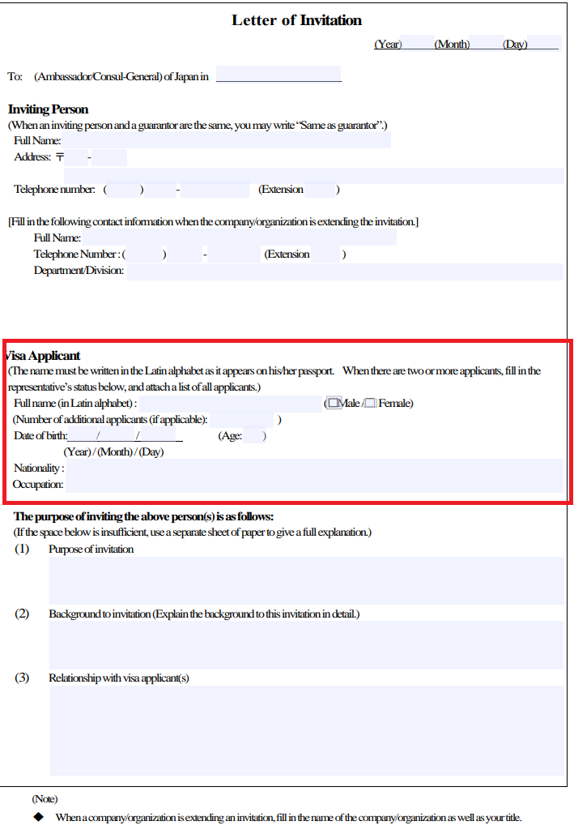

Lists of Required Files and Information
- Travel Itinerary (completed)
- Letter of Invitation (completed)
- Copy of your passport or other form of identification
- Organization Name
- Affiliation
- Position
- Current Address
- Email Address
- Mobile Phone Number
*Note:
・Visa valid for 3 months; applications will be accepted from August 2026.
・This service is only available to those who have paid the participation registration fee.

