Instructions for Preparing Conference Proceedings of ICRP-12/SPP-44

First Author¹, Second Author²

¹ ICRP University, 00-0, xxxxxx, Kanazawa, Ishikawa 000-0000, Japan.
² ICRP Research Center, ICRP University, 00-0, yyyyyy, Kanazawa, Ishikawa 000-0000, Japan

E-mail: zzzzz@icrp-univ.ac.jp

This paper provides you with instructions for preparing the camera-ready proceedings to be submitted to the 12th International Conference on Reactive Plasmas / 44th Symposium on Plasma Processing (ICRP-12/SPP-44). A typical example of the page style and format for the camera-ready proceeding has been described.
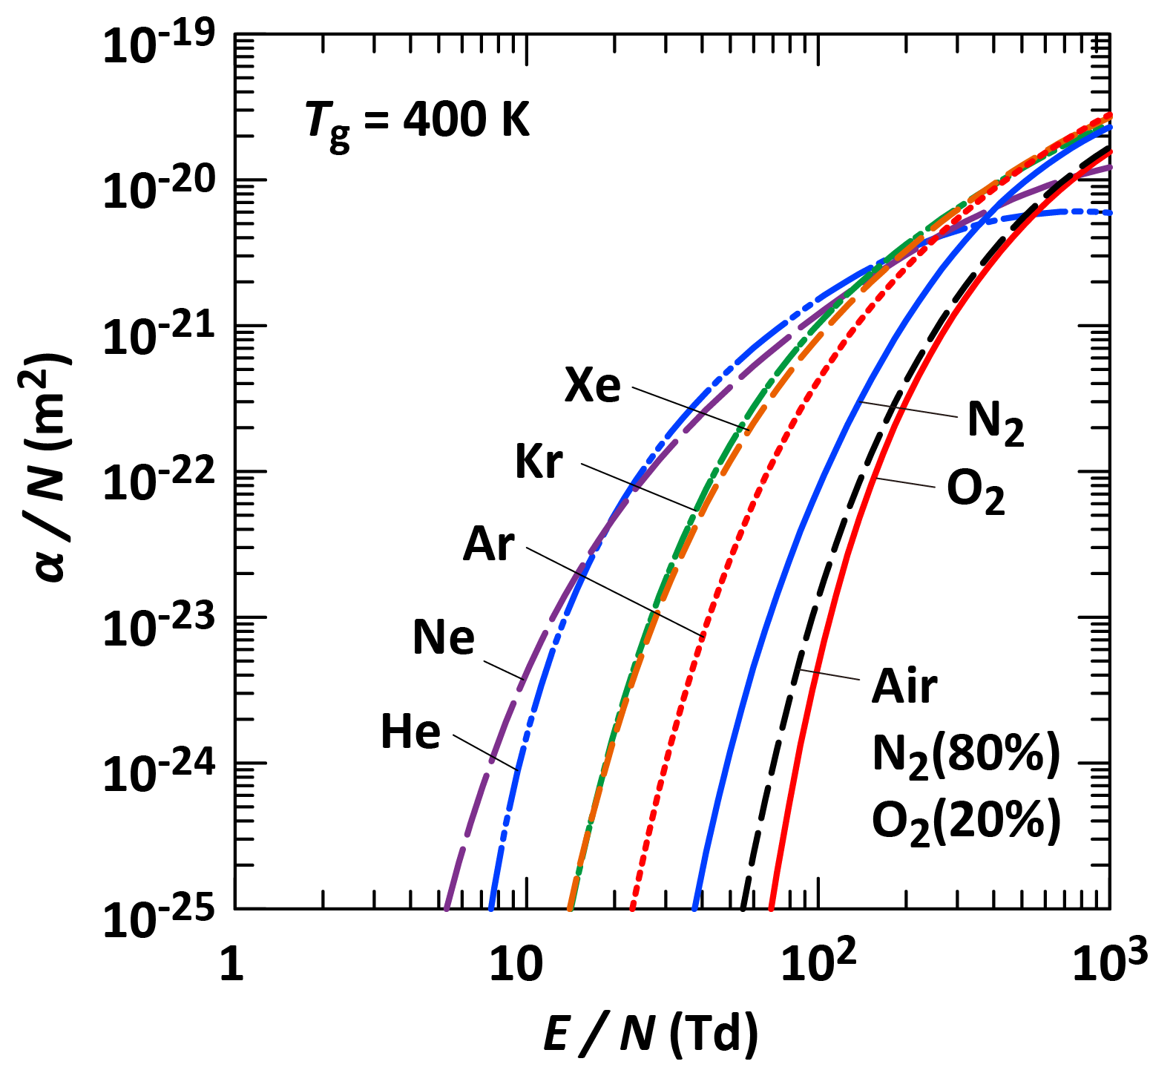
Fig. 1 Ionization coefficient α for noble gases, nitrogen, oxygen, and air.

1. Introduction
This document provides instructions for preparing the camera-ready manuscript for submission to ICRP-12/ SPP-44, including the required style and formatting.
Accepted papers will be published in the Conference Proceedings of ICRP-12/ SPP-44.
Authors must submit a camera-ready paper (maximum two pages) via the conference web submission system:

https://smartconf.jp/content/icrp12/

Submissions by e-mail will not be accepted.

2. Instructions
The proceedings should contain a concise description of the objectives of the study, the methodology, the principal results, and the conclusions.
Submitted manuscripts must be camera-ready and limited to a maximum of two pages. Use vertical A4 size paper (210 × 297 mm). The top, bottom, left, and right margins should be 25 mm, 25 mm, 17 mm, and 17 mm, respectively. The manuscript should be prepared in two columns with a 5 mm space between columns.
The text must be written in English. At the top center of the first page, include the title of the paper, the author name(s), affiliation(s), address(es), the corresponding author’s e-mail address, and the abstract. Leave a blank line between the title and author name(s), between the address(es) and the abstract, and between the abstract and the main text. The abstract should not exceed 100 words.
The main text should be organized into two fully justified columns using single line spacing. Sections should be numbered starting with “1. Introduction.” Leave a blank line between sections. The Acknowledgements and References sections should not be numbered. Page numbers should not be included to facilitate preparation of the conference proceedings.

3. Font, Figures, Tables, Colors, and References
The recommended font is Times or Times New Roman. Fonts using double-byte characters, such as Japanese, Chinese, and Korean fonts, must not be used for either text or figures.
The font sizes for the paper title, author name(s), affiliation(s), abstract, main text, section headings (e.g., “1. Introduction”), and table text should be 14 pt bold, 12 pt bold, 10 pt italic, 10 pt, 10 pt, 10 pt bold, and 9 pt, respectively. The Acknowledgements and References sections may be typed in 9 pt font.
Figures should appear as part of the text and be inserted close to where they are first mentioned. They should be numbered consecutively throughout the paper using Arabic numerals.
When figures are referred to in the text, use “Figure 1” at the beginning of a sentence and “Fig. 1” within a sentence, with a single space between “Figure” or “Fig.” and the following number.
Figure captions should be centered below the figures. Captions should be written in lowercase letters, with an initial capital letter for the first word and for proper nouns only. The preferred font for figure captions is 10-point Times Roman.
Photographs, if included, should be sharp and well contrasted. Color figures are permitted, as the conference proceedings will be distributed in digital format.
Tables should be numbered consecutively throughout the paper using Roman numerals, and each table should be placed in the text close to where it is first referenced.
When tables are referred to in the text, use the full form “Table I,” with a single space between “Table” and the following numeral.
Table I Comparison of key characteristics between CCP and ICP.
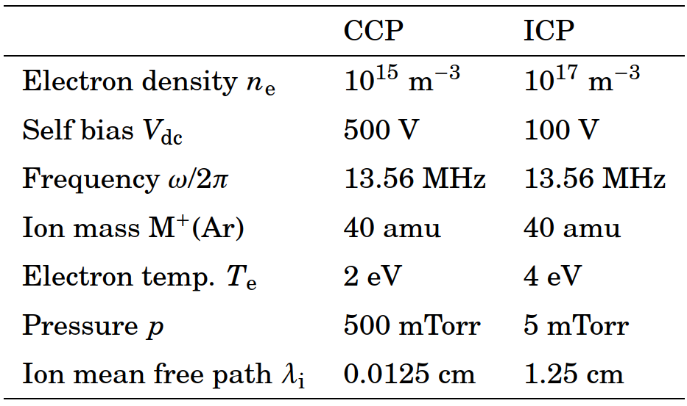
Table headings should always appear above the tables. The preferred font for tables and table headings is 10-point Times Roman.
Mathematical expressions and structural formulae should be prepared with particular care and may be numbered consecutively:
. (1)
However, simple expressions should be kept in the text and written on a single line, e.g., R = a/(b+c).
The reference style in accordance with that of the Japanese Journal of Applied Physics (JJAP) is recommended. When references are cited in the text, the reference number should be indicated in square brackets, e.g., [1]. Journal title abbreviations should follow the Web of Science Journal Title Abbreviations, available at the URL below.

https://wos-help.webofscience.com/WOKRS535R111/help/WOS/A_abrvjt.html

4. Important notice
Prepare a PDF version of your manuscript with all fonts and graphics embedded. Authors should carefully check the PDF file prior to submission. The conference committee is not responsible for correcting files in an incorrect or incomplete format. Each submission must be a PDF file created using this MS Word template and limited to a maximum file size of 10 MB.

Acknowledgements
We would like to cordially express thanks to all contributors to ICRP-12/ SPP-44 for their cooperation in the conference.

References
[1] A. Firstauthor, B. Secondauthor, and C. Thirdauthor, Jpn. J. Appl. Phys. 12, 345 (2010).
[2] E. Editors, Appl. Phys. Lett. 100, 300 (2000).

