Title Should Be in Bold, 16-Point Type and Centered

Lead Author Name^{(a)}, Co-Author Names^{(b)} [11-point type, centered, bolded]
^{(a)} Lead Author affiliation
and one-line address (10-point type, centered, italicized)
^{(b)} Co-Author affiliation (include only if different affiliation, using a,b,c, … references)
and one line address (10-point type, centered, italicized)
Lead Author e-mail address: (10-point type, centered, italicized)

Abstract: Indent left and right margins 12.5 mm, justify the paragraph (on both right and left). Your abstract should be a short (50-150 word) summary of the paper that states the problem, methods used, and major results and conclusions. The extended abstract is restricted to 4 pages

Introduction (11 Point Arial Font)
The appearance of this document reflects the requirements of the style guide. Since there is no typesetting or copy-editing of the 4-page summaries, the use of this style guide is critical to provide a consistent appearance. You can use this style guide as a template.
Use an A4 paper (210 mm x 297 mm) with 25 mm margins on all sides, use 11-point Times New Roman font, and do not use hyphens at the end of a line.
Each paragraph should start flush left and be full justified. Line spacing should be single and paragraph spacing should be 6 points after. Use 1 space after punctuation marks.
Submit your paper as a PDF Paper length should be between 2 and 4 pages, with a target length of 4 pages.

Figures and Tables
Figures and tables should be centered and located inside paper margins. Multiple, smaller figures can be placed side by side. Text should not wrap around figures or tables. Figures and tables should appear as close as possible to where they are mentioned in the main text.
Figure captions (11-point Times New Roman font) should be centered below the figure and table captions (11-point Bold Arial font) should be centered above the table. Captions should be short titles only. Discussion of the figure and table data should appear in the paper text before or after the figure/table.

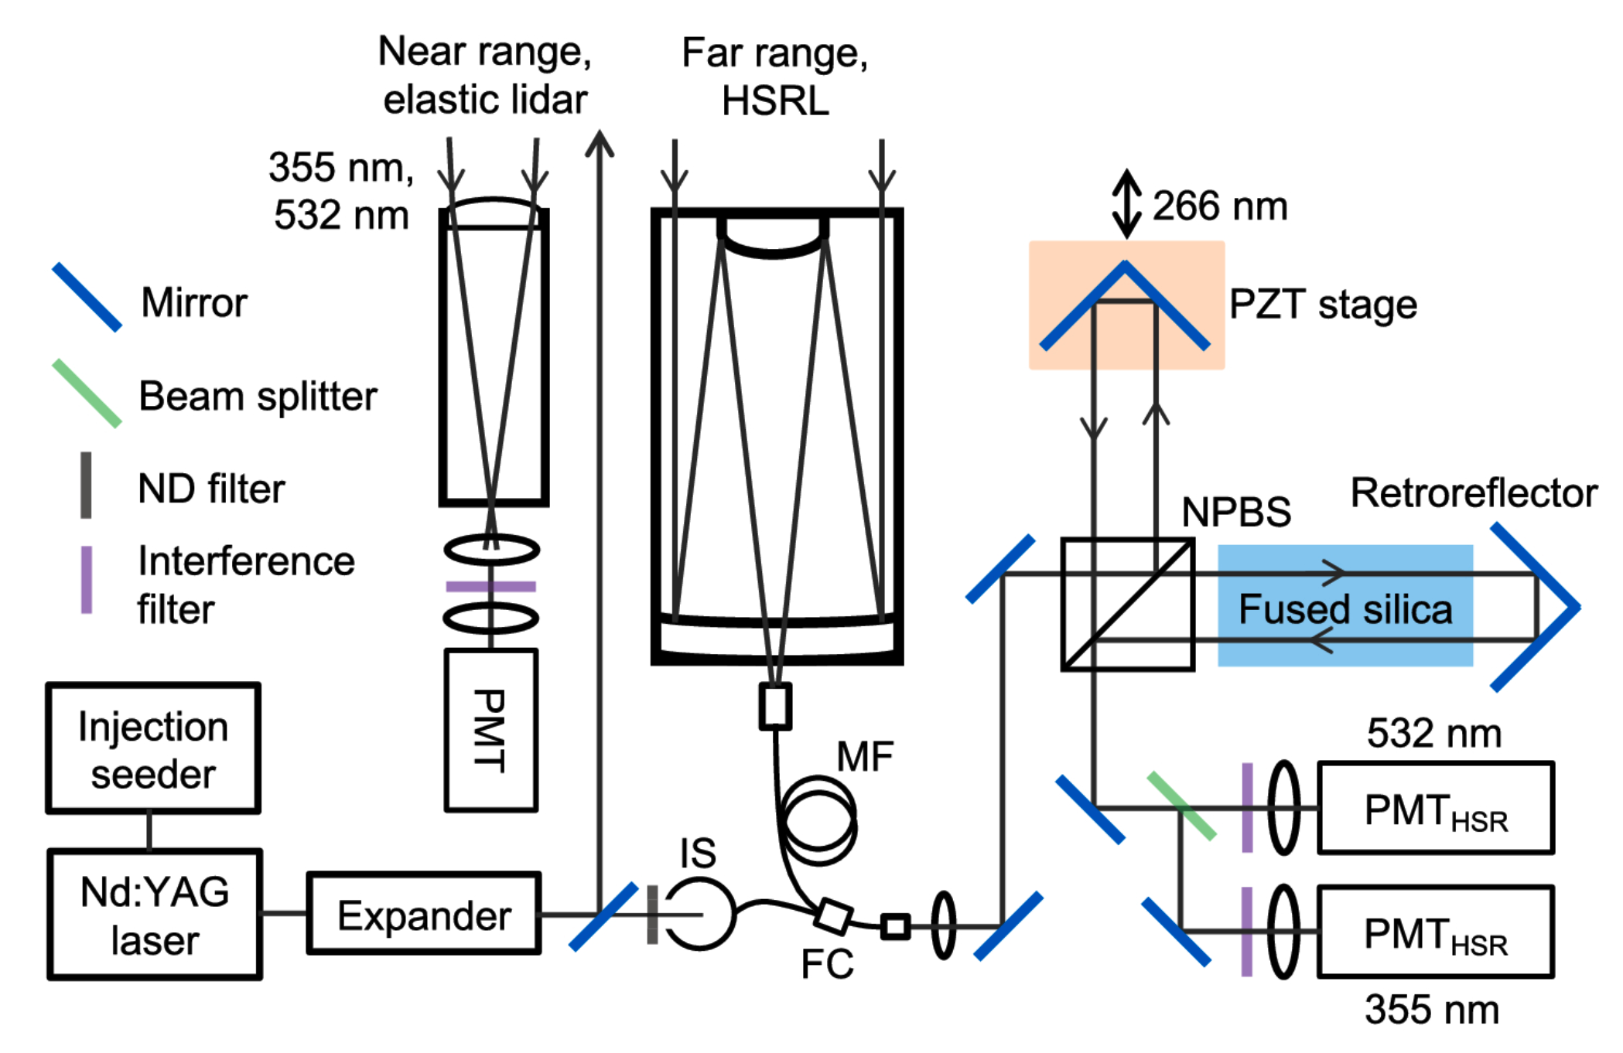
Figure 1. Short descriptive title

Table 1. Short Descriptive Caption
Symbol | Parameter | Value
$$B$$ | Bandwidth | 1 GHz
$$λ$$ | Wavelength | 1064 nm

Equations
Equations (Eqn. 1) should be centered, and equation numbers should only appear to the right of the last line of the equation, in parentheses and right justified. For example:
$$E=hv$$ | (1)
Equations should appear as close as possible to where they are mentioned in the main text.

Numbers and Units
Numbers followed by units should have a space between them, e.g., 1 mm and 10 km.

References
References should appear at the end of the paper in the order in which they are referenced in the body of the paper. The font should be 10 point, and the references should be aligned left. Spacing between references should be 3 points.
Within the main text, references should be designated by a number in brackets [1], and they should be followed by a comma or period [2]. Two references cited at once should be included together [3,4], separated by a comma, while three or more consecutive references should be indicated by the bounding numbers and a dash [1–4].
Example reference formatting instructions for journal papers, book chapters, books, and conference proceedings are provided below.
- C. van Trigt, “Visual system-response functions and estimating reflectance,” JOSA A 14, 741-755 (1997).
- D. F. Edwards, “Silicon (Si)” in Handbook of optical constants of solids, E.D. Palik, ed. (Academic, Orlando, Fla. 1985).
- F. Ladouceur and J. D. Love, Silica-based buried channel waveguides and devices (Chapman & Hall, 1995), Chap. 8.
- Author(s), “Title of paper,” in Title of Proceeding, (Institute of Electrical and Electronics Engineers, New York, 2000), pp. 00-00.

